**Terraform Final Task**

1. **Create VPC**
2. **Create Internet gateway**
3. **Create Custom Route Table**
4. **Create Subnet**
5. **Associate subnet with Route Table**
6. **Create Security Group to allow port 22.80,443**
7. **Create a network interface with an ip in the subnet that was created in step 4**
8. **Assign an elastic IP to the network interface created in step 7**
9. **Create Ubuntu server and install/enable apache2**

**This configuration builds a basic networking setup in AWS:**

* **VPC**
* **Subnet**
* **Internet Gateway**
* **Route Table**
* **Route Table Association**

**Step 1: Create VPC**

**In terraform .main**

**resource "aws_vpc" "my_vpc" {**

**cidr_block = "10.0.0.0/16"**

**enable_dns_support = true**

**enable_dns_hostnames = true**

**tags = {**

**Name = "MyVPC"**

**}**

**}**

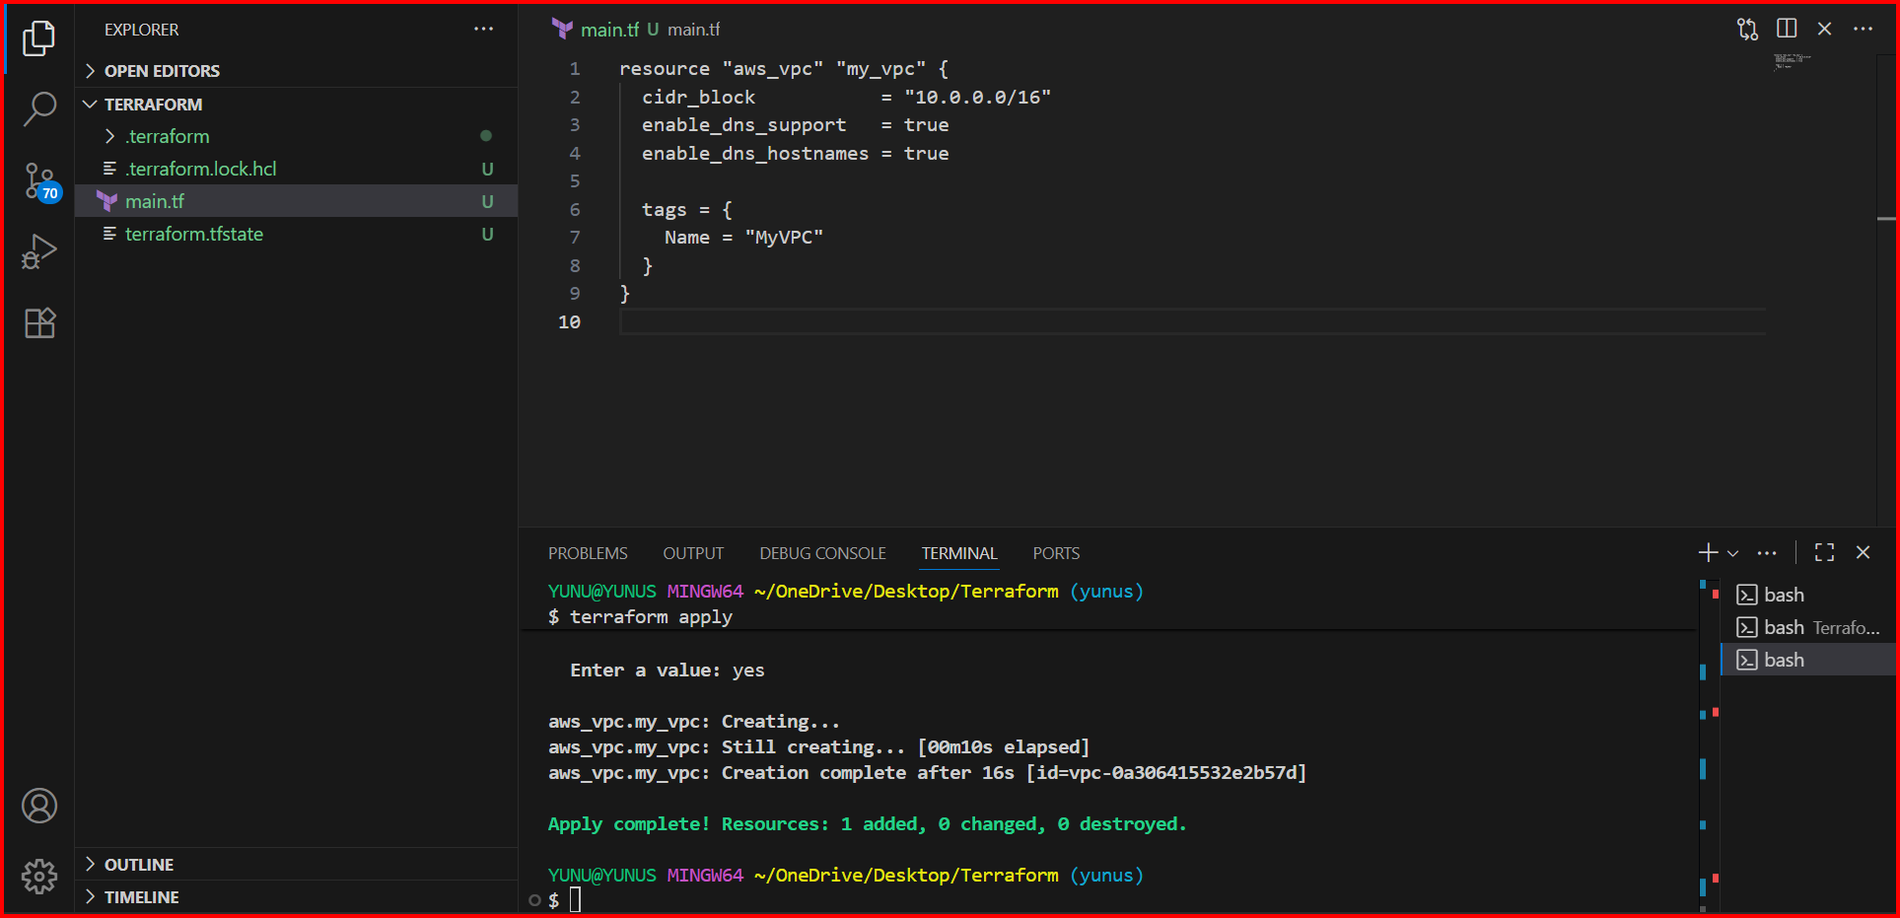

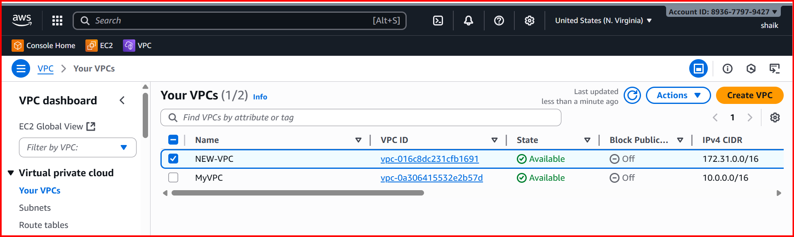

**Step 2: Create Subnet**

**Step 1 & Step 2**

**resource "aws_subnet" "my_subnet" {**

**vpc_id = aws_vpc.my_vpc.id**

**cidr_block = "10.0.1.0/24"**

**availability_zone = "us-east-1a"**

**map_public_ip_on_launch = true**

**tags = {**

**Name = "MySubnet"**

**}**

**}**

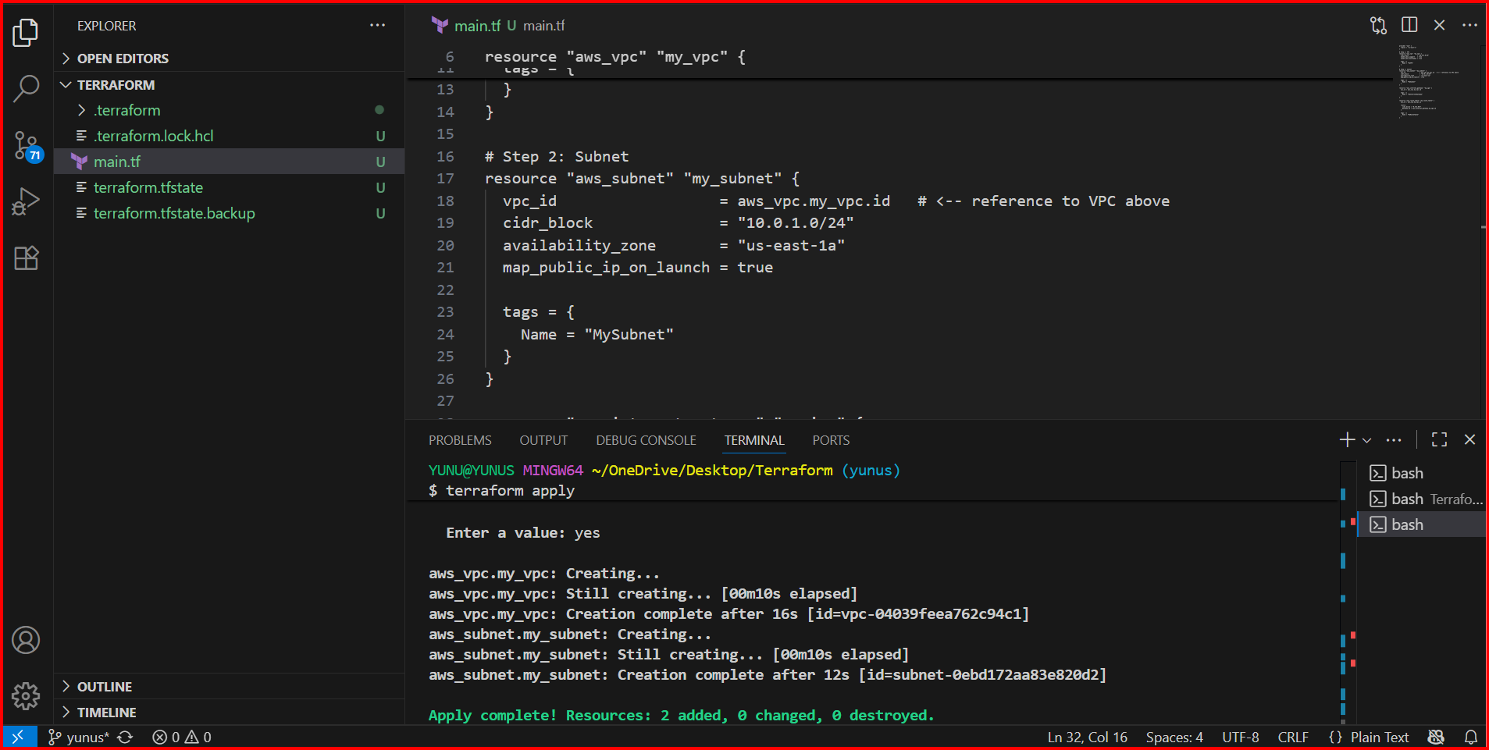

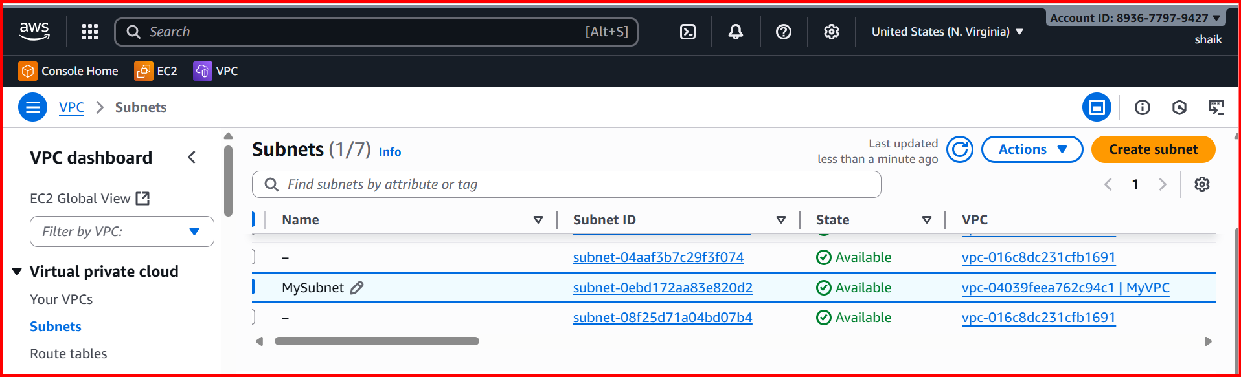

**Step 3: Create Internet Gateway**

**Step1 / Step2 /Step3**

**resource "aws_internet_gateway" "my_igw" {**

**vpc_id = aws_vpc.my_vpc.id**

**tags = {**

**Name = "MyInternetGateway"**

**}**

**}**

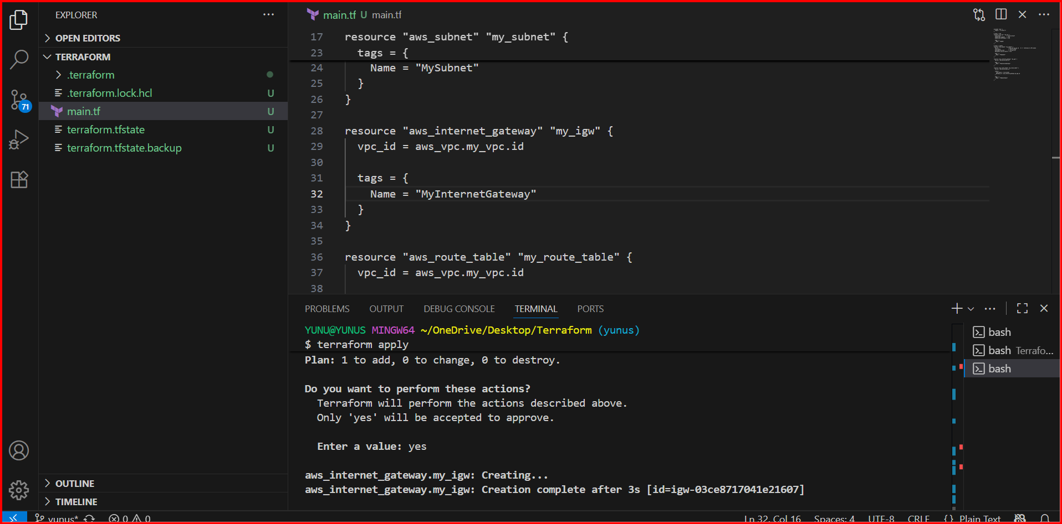

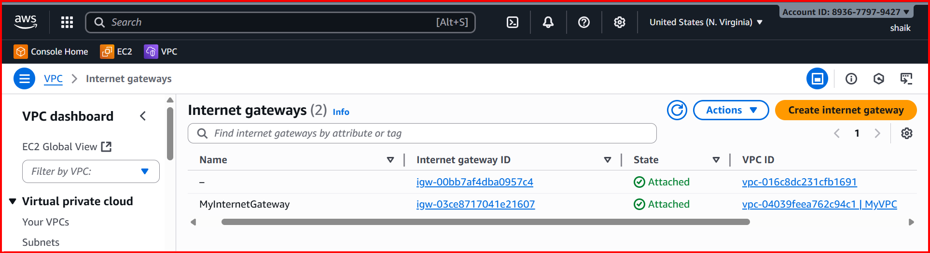

**Step 4: Create Route Table**

**Step1 / Step2 /Step3/Step4**

**resource "aws_route_table" "my_route_table" {**

**vpc_id = aws_vpc.my_vpc.id**

**route {**

**cidr_block = "0.0.0.0/0"**

**gateway_id = aws_internet_gateway.my_igw.id**

**}**

**tags = {**

**Name = "MyRouteTable"**

**}**

**}**

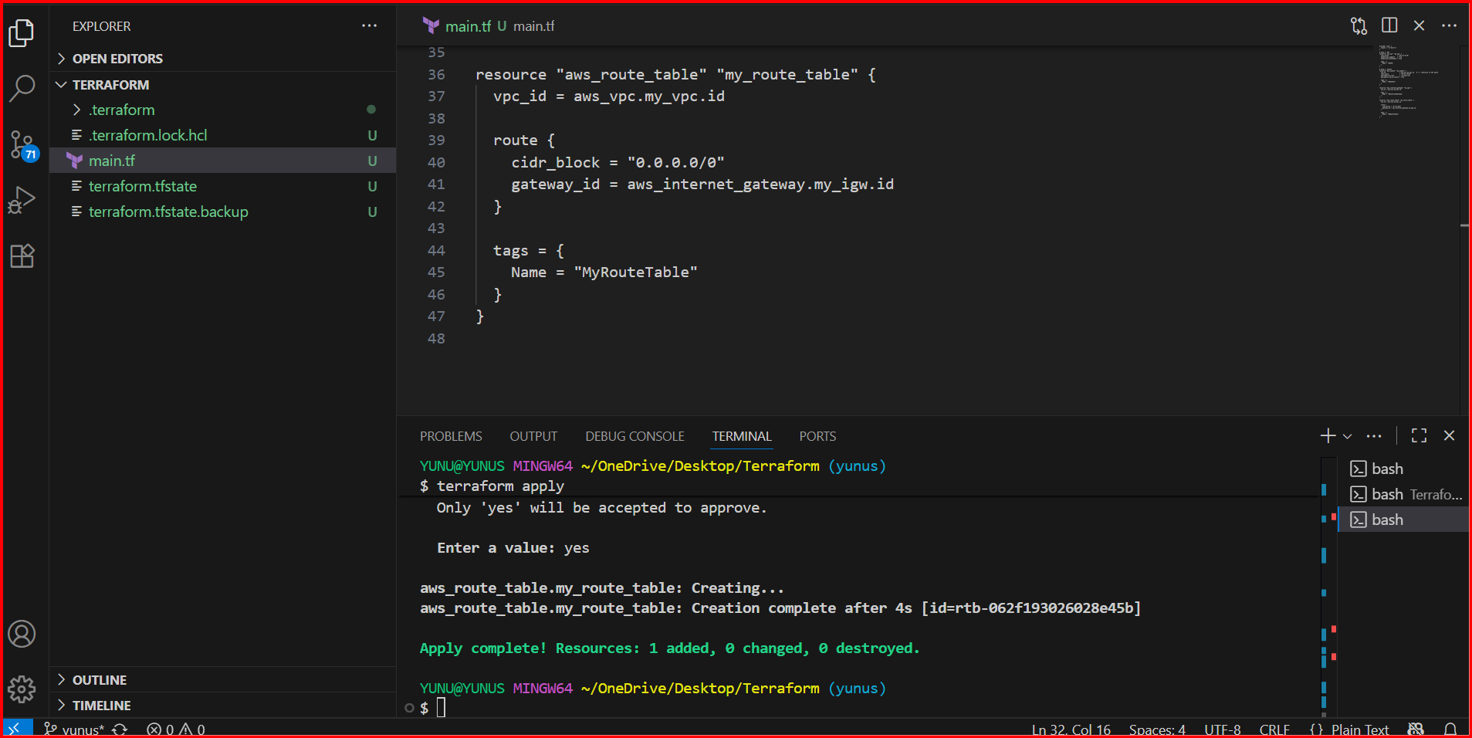

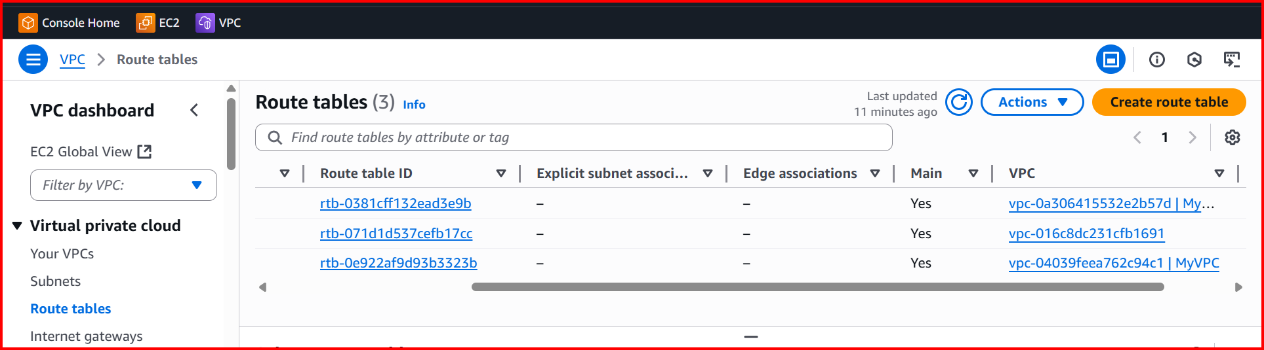

**Step 5: Associate Route Table with Subnet**

**Step1 / Step2 / Step3 /Step4 / Step5**

**resource "aws_route_table_association" "my_route_table_assoc" {**

**subnet_id = aws_subnet.my_subnet.id**

**route_table_id = aws_route_table.my_route_table.id**

**}**

